## **Workshop Assignment: Designing Documentation & Implementation Diagrams**

### **🎯 Objective:**

Help Enterprise Architects document and communicate the technical landscape, integration points, and process details of a Salesforce-based implementation using Salesforce’s four-level Documentation & Implementation diagram approach.

### **📝 Assignment Instructions:**

You are tasked with creating a multi-level diagram set for a fictional Salesforce B2C commerce implementation. Your goal is to:

1. Capture the full solution landscape (Level 1)
2. Zoom into one functional area (Level 2)
3. Detail a process workflow (Level 3)
4. Define the lowest-level system interactions (Level 4)

Select **one domain** from:

* Pharma
* Manufacturing
* Banking

Use the Salesforce products listed below where applicable:

* **Commerce Cloud**, **Service Cloud**, **Marketing Cloud**, **MuleSoft**, **Data Cloud**, **Experience Cloud**, **Order Management**, **Tableau**, **Einstein GPT**

## **🧠 Sample Detailed Solution: Pharma Domain**

### **🔹 Level 1: The Big Picture**

**Title**: Pharma Patient Engagement & Order Fulfillment Landscape  
 **Scope**: End-to-end view of how Salesforce enables a digital transformation for direct-to-patient commerce in pharma.

**Includes**:

* Salesforce Commerce Cloud (for ordering prescription devices)
* Marketing Cloud (for outreach & nurturing)
* Service Cloud (for patient support)
* MuleSoft (for EHR/EMR integrations)
* Data Cloud (for unified patient data)
* Order Management (for pharma distributor integration)

🎯 **Purpose**: Give stakeholders a bird's eye view of all platforms and their high-level connections.

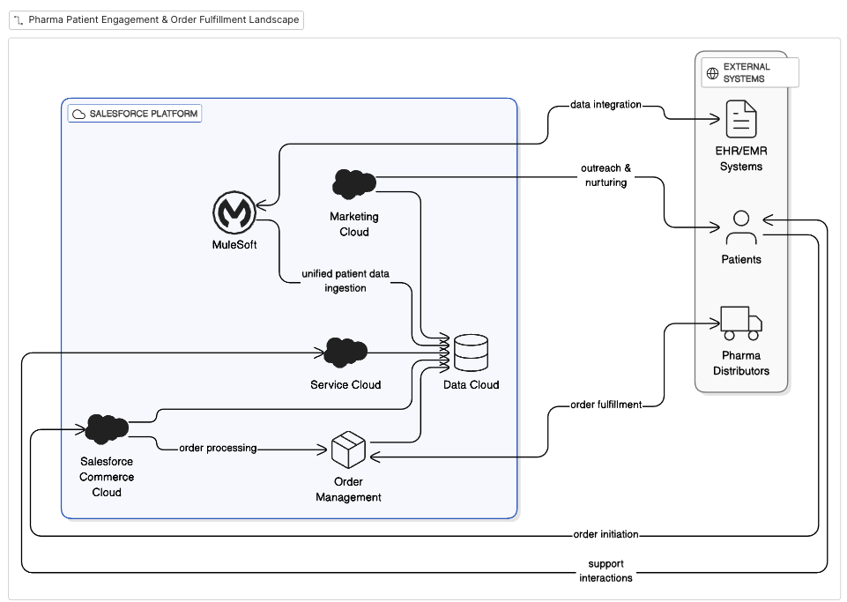

### **🔹 Level 2: Piece of the Whole**

**Title**: Retail Patient Portal & Order Management Layer  
 **Scope**: Zoom in on the patient self-service and prescription fulfillment experience.

**Includes**:

* Experience Cloud: Patient portal interface
* Commerce Cloud: Prescription order entry
* MuleSoft: Checks prescription eligibility with external pharmacy benefit manager (PBM)
* Order Management: Tracks shipment with distributor
* Service Cloud: Embedded support chat

🎯 **Purpose**: Show how a patient order flows across internal and external systems.

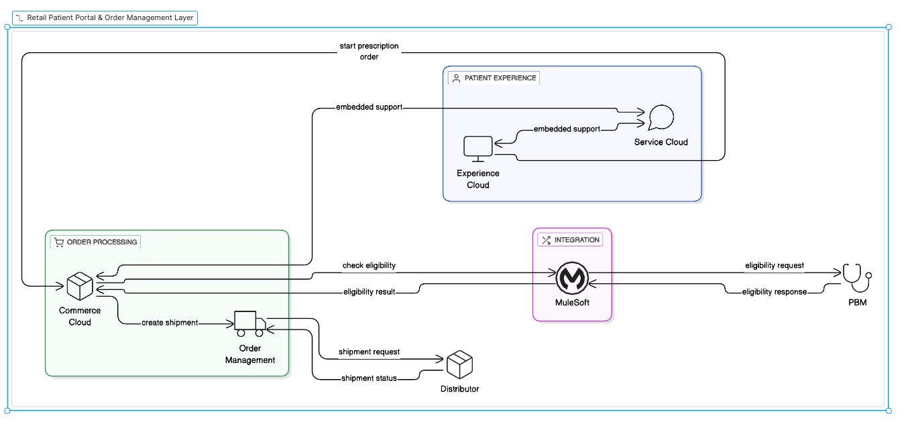

### **🔹 Level 3: Process or Interaction View**

**Title**: Prescription Order Flow (Patient-Driven)  
 **Scope**: Detail the steps taken by a patient placing a prescription order.

**Steps**:

1. Patient logs into portal (Experience Cloud)
2. Views eligibility and coverage (via MuleSoft API call to PBM)
3. Selects delivery option (Commerce Cloud)
4. Order routed to Order Management (OMS)
5. Shipment status updates shown in portal (via MuleSoft from distributor)
6. Einstein Bot offers help / logs a case if issue detected

🎯 **Purpose**: Visualize the real-time orchestration across 6 systems for a single user journey.

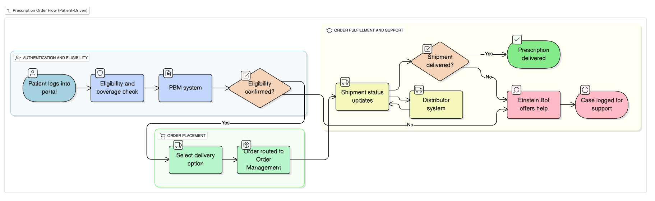

### **🔹 Level 4: The Double Click**

**Title**: Chat-Based Support for Order Disruption  
 **Scope**: Real-time issue resolution via chat channel

**Details**:

* User sends “Where is my order?” in embedded chat
* Einstein GPT classifies intent as “Order Delay”
* Pulls Order ID from Data Cloud profile
* Queries OMS system for status (via MuleSoft)
* If delay detected → Auto-creates Service Case + provides expected resolution ETA
* Human agent notified if escalation rules triggered

🎯 **Purpose**: Show fine-grained data flow, fallback logic, APIs, and real-time personalization logic in a narrow use case.

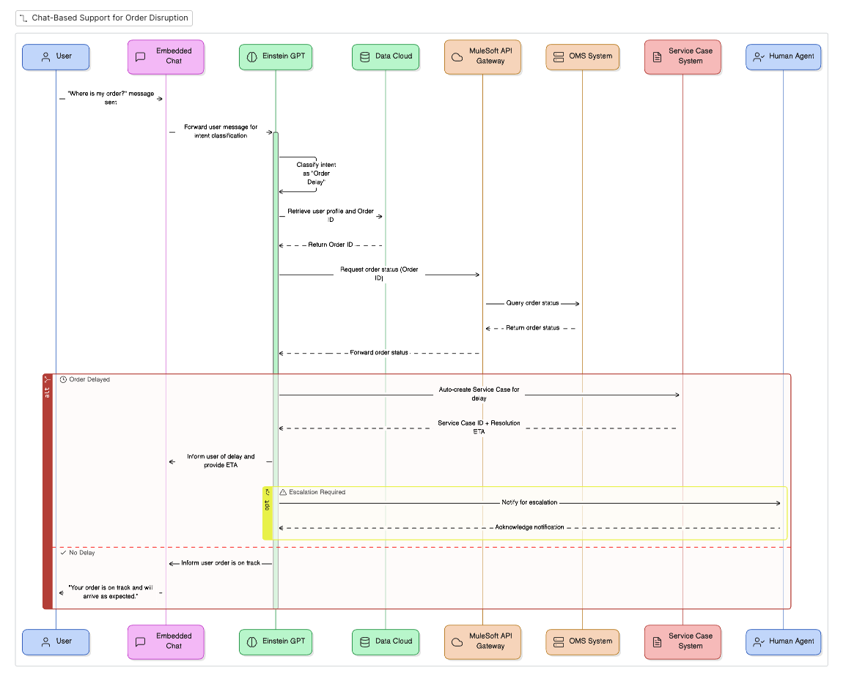

## **🏭 1. Manufacturing Industry – Smart Factory Transformation**

### **Level 1: System Landscape**

**Title**: Smart Factory Salesforce Integration Landscape  
 **Description**: Visualize integration between Salesforce Manufacturing Cloud, IoT Edge Systems, ERP (SAP), and MES. Key capabilities include predictive maintenance, dynamic scheduling, and supplier engagement.

### **Level 2: Production Planning View**

**Title**: Production Forecasting & Order Alignment  
 **Details**: Salesforce Manufacturing Cloud receives real-time inputs from MES and SAP. Production forecast adjustments push updates to suppliers using MuleSoft APIs.

### **Level 3: Process View**

**Title**: Predictive Maintenance to Supplier Reorder  
 **Details**:

* IoT Edge detects a potential machine failure
* Alert sent to Salesforce Service
* Case is logged → triggers automated spare parts reorder via SAP
* Manufacturing Cloud updates inventory planning dashboards

### **Level 4: Data Flow**

**Title**: Spare Part Reorder via Chatbot Interface  
 **Details**:

* User initiates reorder in chat
* Chatbot → Service Cloud → Integration Layer → SAP Purchase Order Creation
* Confirmation & ETA returned to user via same chat thread

## **💊 2. Pharma Industry – Patient Support & Adverse Event Reporting**

### **Level 1: System Landscape**

**Title**: Salesforce Pharma CRM and Safety Ecosystem  
 **Description**: Integrate Salesforce Health Cloud with Veeva Vault (R&D), Oracle Argus (pharmacovigilance), and mobile patient apps. Key flows: adverse event capture, medical rep engagement, care team coordination.

### **Level 2: Adverse Event Capture**

**Title**: Patient Adverse Event Intake via Mobile App  
 **Details**: Event reported via mobile app → stored in Salesforce → routed to Oracle Argus via MuleSoft

### **Level 3: Interaction Flow**

**Title**: Nurse Escalation from Case Intake  
 **Details**:

* Patient submits report
* Triage nurse evaluates severity
* High-risk cases escalate via Health Cloud workflow to medical officer
* Case status and audit trail updated live

### **Level 4: Data Flow**

**Title**: Event Trigger → API POST → Argus  
 **Details**:

* Data validation (duplicate check)
* Case JSON formatted
* Secure API POST to Oracle Argus endpoint
* Response handling and exception logging in Data Cloud

## **🏦 3. Banking Industry – Loan Origination & KYC**

### **Level 1: System Landscape**

**Title**: Retail Banking Customer Lifecycle Architecture  
 **Description**: Connect Salesforce Financial Services Cloud with KYC engines, credit bureaus, core banking systems, and marketing automation. Emphasize customer onboarding, loan servicing, and compliance.

### **Level 2: Loan Origination Architecture**

**Title**: Mortgage Origination Journey  
 **Details**:

* Financial Services Cloud receives application
* Credit score pulled via MuleSoft
* Loan offers generated and routed via OmniStudio to customer

### **Level 3: Process Flow**

**Title**: KYC → Credit Decisioning → Offer Communication  
 **Details**:

* DocuSign for ID upload
* AML/KYC system verifies identity
* Credit Bureau API call
* Loan offer + disclosures generated dynamically and sent to customer portal

### **Level 4: Integration/Data View**

**Title**: MuleSoft API Orchestration  
 **Details**:

* Salesforce call → MuleSoft
* Sequential KYC & credit API calls with fallback
* Aggregated result returned to Salesforce UI
* Logs persisted to Data Cloud